Kinetic and Structural Features of Radical Copolymerization of Acrylonitrile with a Heterocyclic Monomer in Solution Media

L.K.Makhkamova
Tashkent institute chemical technology
Navoi Street, 32, Tashkent, Uzbekistan, 100011
l.maxkamova@mail.ru

The free-radical copolymerization of acrylonitrile (AN) with 1-chloro-3-morpholine propyl acrylate (MCPA) was investigated in dimethylformamide (DMF) using ammonium persulfate as the initiator.The copolymerization behavior was evaluated by determining monomer conversion as a function of polymerization time at different temperatures. The increase in reaction temperature resulted in a higher polymerization rate and monomer conversion. The monomer reactivity ratios were determined using the Fineman–Ross method, confirming the preferential incorporation of MCPA units into the growing copolymer chain. The chemical structure of the synthesized copolymers was confirmed by FTIR and ¹H NMR spectroscopy, while their thermal behavior was evaluated by thermogravimetric analysis (TGA). The TGA results demonstrated a multistage thermal degradation process associated with dehydration, decomposition of side groups, and degradation of the polymer backbone. The obtained results provide new information on the copolymerization behavior, structural characteristics, and thermal stability of AN–MCPA copolymers, demonstrating their potential for the preparation of functional polymeric materials.

1.Introduction
Radical copolymerization is one of the most effective methods for the synthesis of functional polymeric materials with controlled composition and tailored physicochemical properties. The incorporation of heterocyclic monomers containing nitrogen, oxygen, or sulfur atoms into polymer chains significantly improves their thermal stability, chemical resistance, and functional characteristics. Owing to these advantages, radical copolymerization of heterocyclic vinyl monomers has attracted considerable attention in polymer chemistry and materials science (Wang and Debuigne, 2023; Suhara et al., 2026).
Recent studies have demonstrated that heterocyclic acrylate monomers can successfully participate in free-radical copolymerization with vinyl monomers, producing copolymers with improved structural and functional properties. Suhara et al. (2026) synthesized high-refractive-index copolymers based on aromatic heterocyclic monomers, demonstrating the potential of heterocyclic structures for developing advanced functional polymers. Wang and Debuigne (2023) reported that exo-methylene heterocyclic compounds undergo both radical ring-retaining and radical ring-opening polymerization, providing new opportunities for the design of functional polymer architectures. The development of functional polymeric materials has also attracted considerable attention in energy-related applications. Functional polymers and polymer-derived carbon materials have recently been employed as efficient precursors for advanced electrocatalysts used in sustainable hydrogen production. For example, Hubaish et al. (2026) demonstrated that boron-doped porous carbon nanoflakes derived from polymer-containing carbon fabrics exhibit excellent electrocatalytic activity toward the hydrogen evolution reaction (Hubaish et al., 2026). These findings further emphasize the importance of designing functional monomers and copolymers with controlled composition and tailored physicochemical properties. In addition to hydrogen production, functional polymer-derived materials have attracted increasing attention for advanced electrochemical energy-storage systems. Polymer-based Si/C composites have recently demonstrated excellent electrochemical performance as anode materials for rechargeable metal-ion batteries, highlighting the importance of designing polymeric precursors with controlled structure and composition (Mahmood et al., 2026).
The determination of monomer reactivity ratios is an important aspect of copolymerization studies because these parameters allow prediction of copolymer composition and sequence distribution. Zhou et al. (1998) successfully applied the Fineman–Ross method to determine the reactivity ratios of thiophene derivatives, while Smith et al. (2005) demonstrated the high reactivity of cyclic acrylate monomers during radical copolymerization using spectroscopic analysis. These studies confirmed that the relative reactivity of comonomers strongly influences the structure and properties of the resulting copolymers.
Acrylonitrile-based copolymers remain among the most important industrial polymeric materials due to their excellent mechanical properties, thermal resistance, and chemical stability. Recent investigations have shown that the incorporation of functional comonomers can considerably modify their molecular structure and thermal behavior. Liu et al. (2020) demonstrated that functional monomers increase the molecular weight and improve the physical properties of polyacrylonitrile-based copolymers, whereas Tomsa et al. (2020) reported that the incorporation of acrylic acid significantly affects the thermal degradation mechanism of acrylonitrile copolymers. Radical polymerization of acrylonitrile in ionic liquid media has also been successfully investigated by Vygodsky et al. (2005), demonstrating the influence of reaction medium on polymerization efficiency.
Nitrogen-containing heterocyclic compounds have attracted increasing attention because of their wide practical applications in polymer chemistry, pharmaceuticals, and functional materials (Ye and Zhang, 2019). Functional heterocyclic acrylates containing morpholine fragments are especially promising because they combine high polymerization activity with the possibility of introducing polar functional groups into polymer chains.
Despite numerous studies on acrylonitrile-based copolymers, limited information is available regarding the free-radical copolymerization of acrylonitrile with morpholine-containing heterocyclic acrylate monomers. In particular, the effects of the heterocyclic monomer structure on monomer reactivity, copolymer composition, and thermal stability have not been sufficiently elucidated. Therefore, the aim of the present work was to investigate the free-radical copolymerization of acrylonitrile with 1-chloro-3-morpholine propyl acrylate (MCPA), determine the monomer reactivity ratios using the Fineman–Ross method, and characterize the synthesized copolymers by FTIR, ¹H NMR, and thermogravimetric analysis (TGA). The obtained results contribute to a better understanding of the structure–property relationships of functional acrylonitrile-based copolymers and provide useful information for the development of advanced polymeric materials.

2.Methodology
The free-radical copolymerization of acrylonitrile (AN) with 1-chloro-3-morpholine propyl acrylate (MCPA) was carried out in sealed glass tubes. A predetermined amount of ammonium persulfate (APS) was introduced as the initiator, followed by the addition of dimethylformamide (DMF), acrylonitrile, and MCPA in the required molar ratios. The reaction mixture was stirred until complete dissolution of the initiator, purged with nitrogen to remove dissolved oxygen, sealed, and placed in a thermostatically controlled Wited thermostat.
The copolymerization was performed at 30, 40 and 50 ± 0.1 °C. The reaction was terminated at a monomer conversion of approximately 7.7% in order to minimize compositional drift during copolymerization. After cooling to room temperature, the copolymers were precipitated from the DMF solution by adding excess ethanol. The precipitation procedure was repeated twice, after which the precipitated copolymers were filtered and vacuum-dried to constant weight. The obtained copolymers were white powdery solids readily soluble in dimethyl sulfoxide (DMSO), dimethylformamide (DMF), and acetone. Monomer conversion was determined gravimetrically.
Each copolymerization experiment was performed independently in triplicate (n = 3) under identical experimental conditions. The reported values represent the mean ± standard deviation. The experimental error of the gravimetric determination of monomer conversion did not exceed ±3%, confirming good reproducibility of the obtained results.
The monomer reactivity ratios were calculated using the Fineman–Ross method based on low-conversion copolymerization data.
FTIR spectra of the starting monomers and synthesized copolymers were recorded on a SISTEM-200 FTIR spectrophotometer over the range of 400–4000 cm⁻¹ using KBr pellets. ¹H NMR spectra were obtained in CD₃COCD₃ solutions on a Variant-6 spectrometer operating at 60 MHz at 30 °C, using tetramethylsilane (TMS) as the internal reference. Thermogravimetric (TGA) and differential thermal (DTA) analyses were performed on a DTG-60 thermal analyzer (Shimadzu, Japan).

3. Result and discussion
The free-radical copolymerization of acrylonitrile (AN) with 1-chloro-3-morpholine propyl acrylate (MCPA) was carried out in dimethylformamide (DMF) using ammonium persulfate as the radical initiator. Preliminary experiments showed that polymerization in aqueous media proceeded through a heterogeneous mechanism, whereas DMF provided a homogeneous reaction medium with improved monomer compatibility and a higher polymerization rate. Therefore, DMF was selected as the reaction medium for the kinetic investigation. The apparent activation energy of the copolymerization process was estimated to be 47.77 kJ mol⁻¹, indicating that the copolymerization proceeds under typical free-radical conditions and is comparable with values reported for similar acrylonitrile-based copolymer systems.
To minimize compositional drift during copolymerization, all kinetic measurements and copolymer composition analyses were performed at low monomer conversion (approximately 7.7%). Under these conditions, the instantaneous copolymer composition closely reflects the initial monomer feed composition, allowing reliable determination of the monomer reactivity ratios by the Fineman–Ross method.
Figure 1 shows that increasing the reaction temperature from 30 to 50 °C significantly accelerates the copolymerization process and increases monomer conversion. This behavior is attributed to the higher decomposition rate of ammonium persulfate, resulting in a greater concentration of active radicals. Therefore, subsequent copolymer composition analyses were performed at a low conversion (~7.7%) to minimize compositional drift.
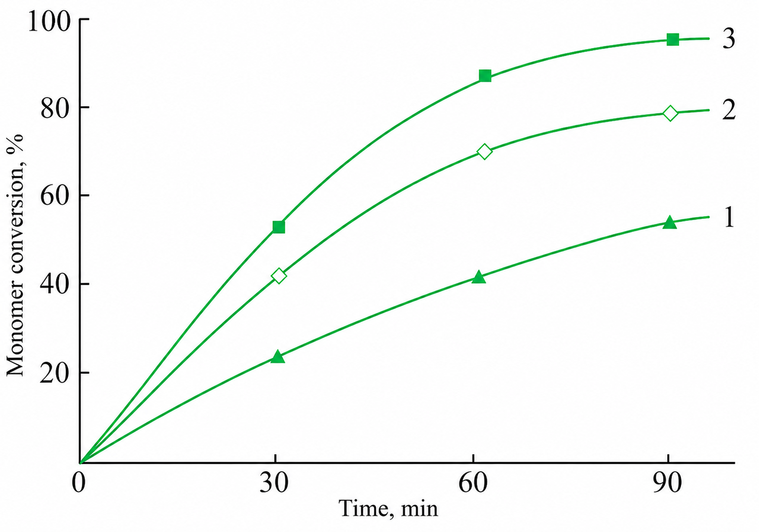
Figure 1. Effect of temperature on monomer conversion during the free-radical copolymerization of acrylonitrile with MCPA in DMF in the presence of ammonium persulfate (5 × 10⁻³ mol L⁻¹): (1) 30 °C, (2) 40 °C, and (3) 50 °C.
The influence of the initial monomer composition on the copolymer composition was investigated over a wide range of feed ratios, and the results are summarized in Table 1.
Table 1: Dependence of copolymer composition on the monomer ratio in the initial mixture of MCPA (M₁) with AN (M₂ ) in a DMF medium. [PA]=5∙10⁻³ mol/l; t=50 ^{о}C.
Initial ratio, mole fraction |  | Chlorine content, % | Yield, % | Copolymer composition, mole fractions
М ₁ | М ₂ | Chlorine content, % | Yield, % | m ₁ | m ₂
0,20 | 0,80 | 4,2 | 3,3 | 0,28 | 0,72
0,35 | 0,65 | 5,8 | 4,2 | 0,38 | 0,62
0,50 | 0,50 | 6,8 | 5,7 | 0,45 | 0,55
0,65 | 0,35 | 7,9 | 6,8 | 0,52 | 0,48
0,80 | 0,20 | 9,9 | 7,7 | 0,65 | 0,35
As shown in Table 1, the copolymer composition differs from the initial monomer feed, indicating different reactivities of AN and MCPA during free-radical copolymerization. At low MCPA content, the resulting copolymer contains a slightly higher proportion of MCPA units than expected from the feed composition, suggesting preferential incorporation of the heterocyclic monomer at the initial stage of polymerization. As the AN content increases, the proportion of AN units in the copolymer also increases, resulting in reduced water solubility due to the higher content of nitrile groups. These results demonstrate that the copolymer composition is governed by the relative reactivities of the two monomers and confirm the suitability of the obtained experimental data for determining the monomer reactivity ratios using the Fineman–Ross method(Figure 2).

. 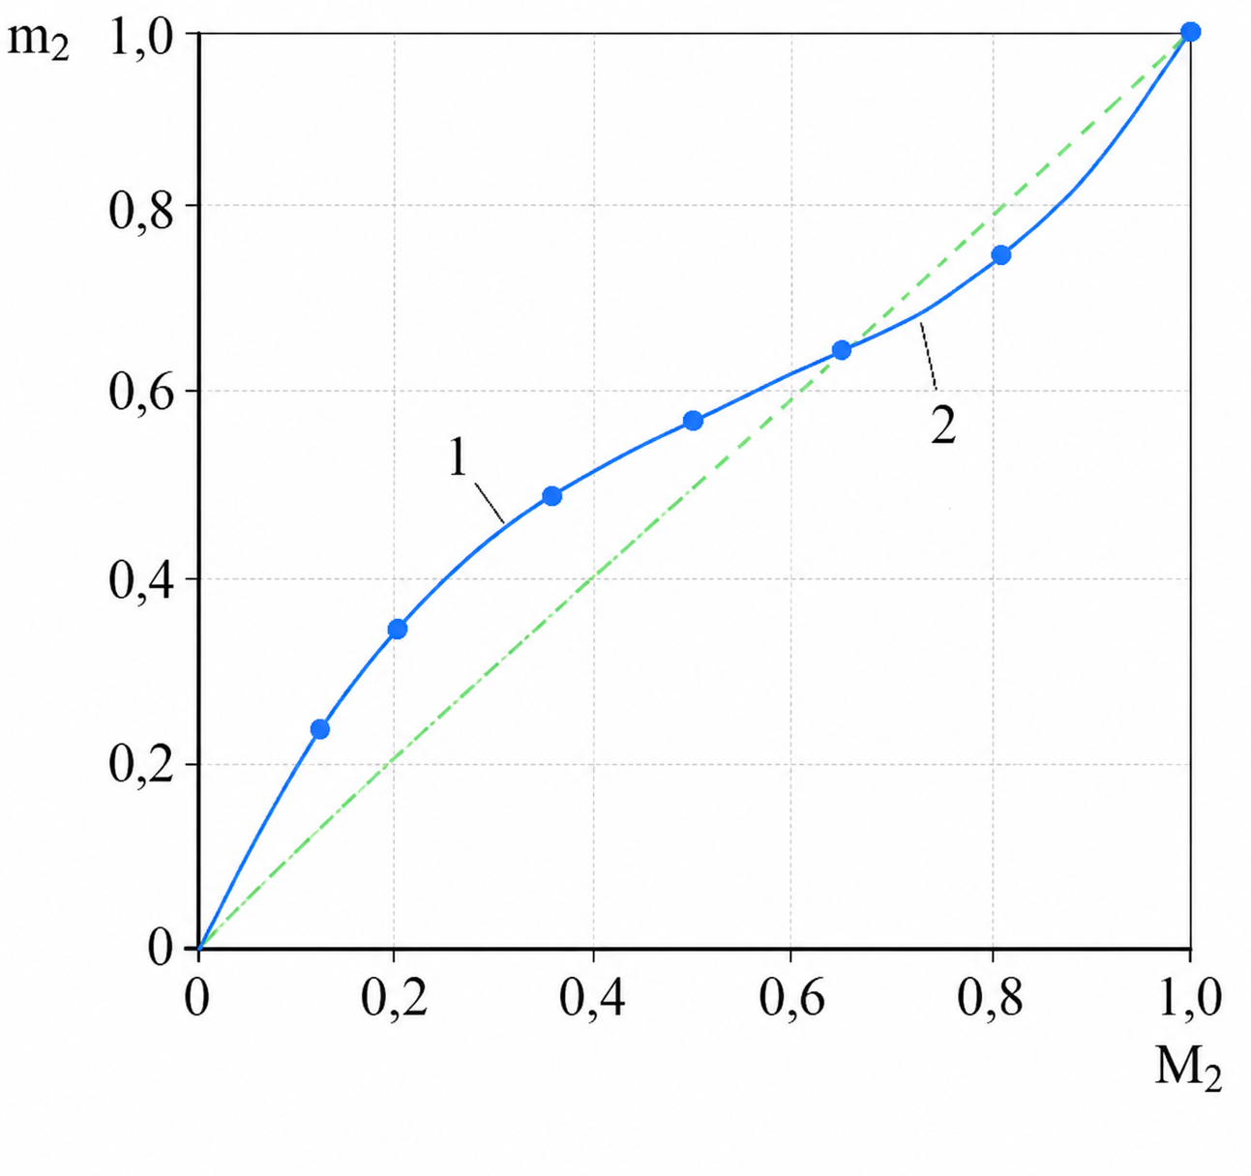
Figure 2: Fineman–Ross plot for determining the monomer reactivity ratios in the AN–MCPA copolymerization system.
The monomer reactivity ratios were determined using the linearized Fineman–Ross equation. As illustrated in Figure 2, the experimental copolymer composition data exhibit a satisfactory linear relationship, confirming the applicability of the Fineman–Ross model to the AN–MCPA copolymerization system. The graphical analysis was used to calculate the reactivity ratios of the comonomers, and the corresponding numerical values are summarized in Table 2.
Table 2: Quantitative values of the relative reactivity of comonomers in AN-MCPA system
Systems | r₁ | r₂ | 1/r₁ | 1/r₂ | r₁ ∙r₂
AN-MCPA | 0,25 | 0,80 | 4,0 | 1,25 | 0,20
The monomer reactivity ratios obtained for the AN–MCPA system were r₁ = 0.25 and r₂ = 0.80. Since both values are lower than unity, the propagating radicals preferentially react with the opposite monomer rather than with the same monomer species. The product of the reactivity ratios (r₁r₂ = 0.20) is significantly lower than unity, indicating a pronounced tendency toward alternating incorporation of AN and MCPA units into the growing polymer chain. This behavior can be attributed to the different electronic characteristics of the nitrile group in AN and the morpholine-containing acrylate fragment in MCPA, which promote cross-propagation during free-radical copolymerization. The linear regression analysis yielded R² = 0.996, indicating excellent agreement between the experimental data and the Fineman–Ross model and confirming the reliability of the calculated reactivity ratios. Consequently, the synthesized copolymers are expected to possess a more uniform distribution of functional units along the polymer backbone.
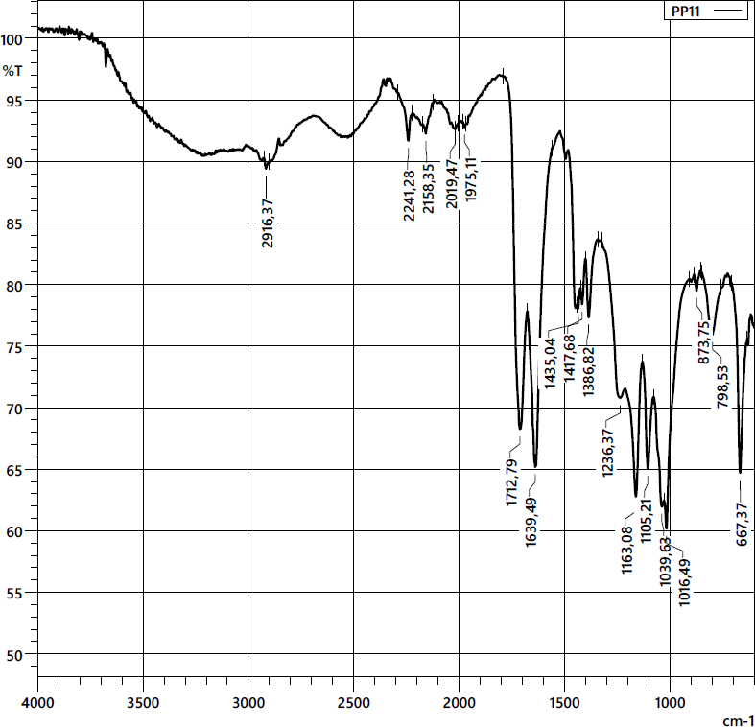
The chemical composition and structural characteristics of the synthesized copolymers were verified using elemental analysis in combination with FTIR and ¹H NMR spectroscopy. The FTIR spectra of the AN–MCPA copolymer synthesized at an initial monomer ratio of 0.65:0.35 and low monomer conversion are presented in Figure 3.

Figure 3: IR spectrum of copolymer based on AN with MCPA at a ratio of 0.65:0.35
The IR spectroscopic analysis confirms the formation of a new copolymer based on AN and MCPA. In the spectra of the obtained samples absorption bands corresponding to MCPA structural units are clearly observed in the region 1712 cm⁻¹ and 1236 cm⁻¹, which are attributed to ester groups. The characteristic carbonyl (C=O) stretching vibrations appear at 1639 cm⁻¹, while the nitrile (C≡N) functional group gives absorption bands in the range 2242 cm⁻¹. In addition, symmetric CH₂ stretching vibrations are detected at 1435 cm⁻¹. Notably, the absence of absorbtion bands associated with C=C double bonds in the IR spectra indicates that the copolymerization occurs through the vinyl functionalities of the initial monomers, confirming the successful formation of the polymer backbone.
The structure of the synthesized copolymers was further confirmed by ¹H NMR spectroscopy (Figure 4).
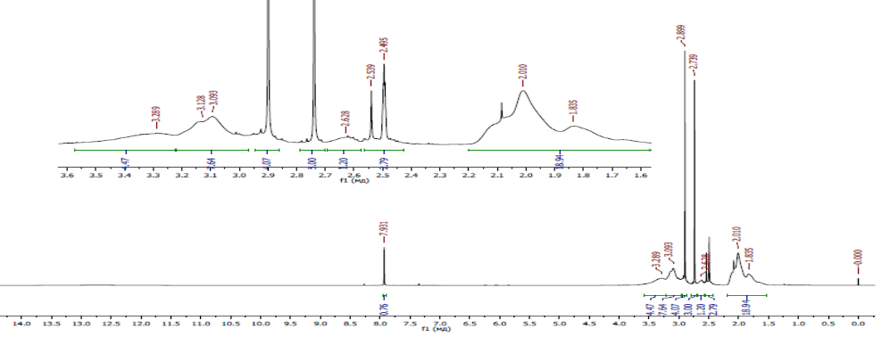
Figure 4: ¹H NMR spectrum of the AN-MCPA copolymer at 1:1 monomer ratio.
In the ¹H NMR spectrum of the AN–MCPA copolymer in figure 4, two regions are observed at 1.8–1.9 and 1.9–2.2 ppm, which can be attributed to the resonance of protons from methyl and methylene groups. The signal at around 3.3 ppm is characteristic of methylene protons adjacent to oxygen (–OCH₂–), while the methylene group of the copolymer backbone (–CH₂–) appears at approximately 2.45 ppm.
Thus, based on the results of elemental analysis as well as IR and NMR spectroscopic data, the structure of the copolymers derived from AN and MCPA can be represented by the following reaction schemes:
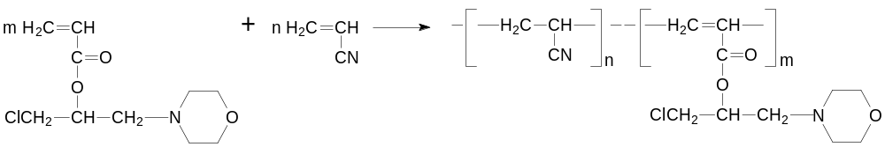

To evaluate the thermal stability and thermal degradation of the AN-MCPA copolymers, thermogravimetric analysis was carried out in Figure 5.
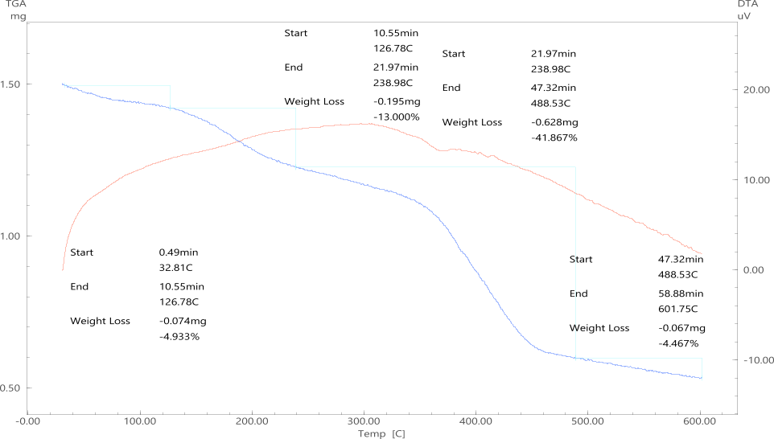
Figure 5: Thermogram of the AN-MCPA copolymer at a 0.65:0.35 monomer ratio.
The thermogravimetric (TGA) and differential thermal analysis (DTA) curves of the synthesized AN–MCPA copolymer are shown in Figure 5. The thermal degradation proceeds through three main stages, indicating a multistep decomposition mechanism typical of functional acrylonitrile–acrylate copolymers.The first stage (32.8–126.8 °C) is characterized by a weight loss of 4.93%, which is attributed to the evaporation of physically adsorbed moisture and residual dimethylformamide entrapped within the polymer matrix. No significant structural degradation occurs in this temperature range.The second stage (126.8–238.9 °C) results in a weight loss of approximately 13.00%. This stage is associated with the thermal decomposition of the ester groups and the initial degradation of the 1-chloro-3-morpholine propyl side chains. The polymer backbone remains largely intact, indicating that decomposition starts from the pendant functional groups.
The principal degradation stage occurs between 238.9 and 488.5 °C, where the copolymer loses 41.87% of its mass. This major weight loss is attributed to random scission of the macromolecular backbone together with decomposition of the nitrile-containing acrylonitrile segments and fragmentation of the acrylate units. The DTA curve exhibits a pronounced thermal effect in this region, confirming that the main-chain degradation takes place within this temperature interval.Above 488.5 °C, only a small additional weight loss (4.47%) is observed up to 601.8 °C. This stage corresponds to carbonization and gradual decomposition of the remaining carbonaceous residue, leading to the formation of a thermally stable char.
The obtained thermal behavior is consistent with that reported for structurally related acrylonitrile–acrylate copolymers, in which degradation begins with cleavage of pendant ester groups followed by destruction of the polymer backbone at higher temperatures. The incorporation of morpholine-containing MCPA units does not significantly reduce the thermal stability of the copolymer while providing additional functional characteristics. Overall, the synthesized AN–MCPA copolymer demonstrates satisfactory thermal stability for potential applications requiring moderate heat resistance.

4. Conclusions
AN–MCPA copolymers were successfully synthesized by free-radical copolymerization. FTIR, ¹H NMR, and TGA analyses confirmed the chemical structure and thermal stability of the obtained copolymers. The Fineman–Ross reactivity ratios (r₁ = 0.25, r₂ = 0.80) indicated preferential cross-propagation and a tendency toward alternating incorporation of the comonomers. Increasing the polymerization temperature accelerated the reaction and increased monomer conversion. Thermogravimetric analysis showed that the main degradation stage started above 239 °C, demonstrating satisfactory thermal stability. These results indicate that the synthesized AN–MCPA copolymers are promising functional polymeric materials.b
References
Aljamali N.M., Alfatlawi I.O., 2015, Synthesis of sulfur heterocyclic compounds and study of expected biological activity, Research Journal of Pharmaceutical Technology, 8(9), 1225–1231.
Deryabina G.I., 2013, Copolymerization, Samara University Publishing House, Samara, Russia.
Feng M., Tang B., Liang S.H., Jiang X., 2016, Sulfur-containing scaffolds in drugs: Synthesis and application in medicinal chemistry, Current Topics in Medicinal Chemistry, 16(11), 1200–1216.
Hubaish S.M., Saad M., Eljack F., Chitt M., Makhkamova L., Eid K., 2026, Porous carbon nanoflakes doped with boron derived from carbon fabric containing polyester as efficient electrocatalysts for green hydrogen production, Polymers, 18(9), 1107. DOI: 10.3390/polym18091107
Liu P., Zhang N., Yi Y., Gibril M.E., Wang S., Kong F., 2020, Effect of lignin-based monomer on controlling the molecular weight and physical properties of the polyacrylonitrile/lignin copolymer, International Journal of Biological Macromolecules, 164, 2312–2322.
Mahkamova L., 2023, Copolymerization of acrylonitrile with a nitrogen-containing ester, E3S Web of Conferences, 434, 02031.
Mahmood S.A., Mobarak N.N., Khudayberdieva A., Doghmane M., Chettibi S., Eid K., 2026, Silicon carbide (SiC) and silicon/carbon (Si/C) composites for high-performance rechargeable metal-ion batteries, Polymers, 18(9), Article 1107.
Smith Q., Huang J., Matyjaszewski K., Loo Y.-L., 2005, Controlled radical polymerization and copolymerization of 5-methylene-2-phenyl-1,3-dioxolan-4-one by ATRP, Macromolecules, 38(13), 5581–5586.
Suhara Y., Sato K., Samitsu S., Mori H., 2026, High-refractive-index copolymers produced by radical copolymerization of aromatic heterocyclic monomers in deep eutectic solvents, RSC Applied Polymers.
Tomsa R.V., Balashova M.S., Shaovaa A.A., Gerval'da A.Yu., Prokopova N.I., Plutalova A.V., Grebenkina N.A., Chernikova E.V., 2020, Copolymers of acrylonitrile and acrylic acid: Effect of composition and distribution of chain units on the thermal behavior of copolymers, Polymer Science Series B, 62(2), 102–115.
Vygodsky Y.S., Melnik O.A., Lozinskaya E.I., Shaplov A.S., 2005, Radical polymerization and copolymerization of acrylonitrile in ionic liquids, High Molecular Compounds Series B, 47(4), 704–709.
Wang Z., Debuigne A., 2023, Radical polymerization of methylene heterocyclic compounds: Functional polymer synthesis and applications, Polymer Reviews, 805–851.
Ye Z., Zhang F., 2019, Recent advances in constructing nitrogen-containing heterocycles via electrochemical dehydrogenation, Chinese Journal of Chemistry, 37(5), 513–528.
Zhou L., Li Y., Xue G., 1998, A study of electrochemical copolymerization of 3-butylthiophene and 3-bromothiophene, Thin Solid Films, 335(1–2), 112–116.

